In Vitro interaction of Amoxicillin with Vildagliptin and Investigation of Antimicrobial Activity.

A project report submitted to the Department of Pharmacy,
University of Science & Technology , Chittagong(USTC) , in the partial fulfillment of requirements for the degree of Bachelor of Pharmacy (B. Pharm)



Submitted By:
Examination Roll No: 1236 Registration No: 1236
Session: January, 2020
29th Batch

Department of Pharmacy ( B. Pharm) University of Science & Technology, Chittagong (USTC)
Foy’s Lake , Chittagong , Bangladesh
November, 2024

Dedicated To My
Beloved Parents
& Honorable Teachers

Abstract

The research work comprises of interaction studies of Amoxicillin with anti-diabetic drug. Amoxicillion is a synthetic broad spectrum antimicrobial agent for oral administration. Amoxicillion is an antibiotic which falls under the group of drugs called aminopenicillin. Amoxicillion is used to treat different types of bacteria in the body.
Since the presence of complex forming ligand may affect the bioavailability of an anti- diabetic drug in the blood or tissues, therefore, to study the probable interaction of Amoxicillin with essential and trace elements present in the body. Amoxicillion has been interacted with Vildagliptin in vitro.
The studies are carried out in buffer at pH 1.75 in variable ratios of drug and Vildagliptin at room temperature conditions. It has been observed that almost major proportion of drug forms complexes with Vildagliptin.
There is an effect of pH on drug complexation. It has been observed that amoxicillion interacts with Vildagliptin at pH 1.75. The ultraviolet studies of these complexes were carried out and compared.

TABLE OF CONTENT

Sl. No. | Chapter Particulars | Page No.
 | Abstract
 | Chapter-1:introduction | 1
1.1 | Occurrence of drug interaction | 4
1.2 | Effect of Drug Interaction | 4
1.3 | Mechanism of Drug Interaction | 4
1.3.1 | Pharmacokinetics Drug Interaction | 5
1.3.2 | Pharmacodynamics Drug Interaction | 7
1.4 | How can drug can be avoided | 8
1.5 | Drug-drug interaction | 8
1.6 | Drug Profile(Amoxicillin) | 9
1.7 | Drug Profile(Vildagliptin) | 20

 | Chapter-2: Literature Review | 26
 | Chapter-3: Aim of the work | 33
 | Chapter-4: Materials and Method | 35
4.1 | Chemical and Reagents | 36
4.2 | Instruments and equipment’s | 36
4.3 | Methods | 37
 | Chapter-5: Results and Discussion | 41
 | Chapter-6: Antimicrobial study | 45
 | Chapter-7: Conclusion | 53
 | References | 55

Chapter-1 Introduction

Introduction
A drug interaction is a situation in which a substance affects the activity of a drug, i.e. the effects are increased or decreased, or they produce a new effect that neither produces on its own. Typically, interaction between drugs come to mind (drug-drug interaction). However, interactions may also exist between drugs & foods (drug-food interactions), as well as drugs & herbs (drug- herb interactions). People taking antidepressant drugs such as Monoamine oxidase inhibitors should not take food containing tyramine. Hypertensive crisis may occur (An example of drug- food interactions). These may occur out of accidental misuse or due to lack of knowledge about the active ingredients involved in the relevant substances.
Drug interactions may also occur outside the body i.e.; in-vitro. Some classic examples include that thiopentone and suxamethonium should not be placed in the same syringe and same for benzylpenicillin and heparin.
Generally speaking, drug interactions are to be avoided, due to the possibility of poor or unexpected outcomes. However, drug interactions have deliberately used, such as co- administering probenecid with penicillin prior to mass production of penicillin. Because penicillin was difficult to manufacture, it was worthwhile to find a way to reduce the amount required. Probenecid retards the excretion of penicillin, so a dose of penicillin persists longer when taken with it, and it allowed patients to take less penicillin over a course of therapy.
A contemporary example of a drug interaction used as an advantage is the co-administration of carbidopa with levodopa (available as Carbidopa/levodopa). Levodopa is used in the management of Parkinson's disease and must reach the brain in an un-metabolized state to be beneficial. When given by itself, levodopa is metabolized in the peripheral tissues outside the brain, which decreases the effectiveness of the drug and increases the risk of adverse effects. However, since carbidopa inhibits the peripheral metabolism of levodopa, the co-administration of carbidopa with levodopa allows more levodopa to reach the brain un-metabolized and also reduces the risk of side effect.
Drug interactions may be the result of various processes. These processes may include alterations in the pharmacokinetics of the drug, such as alterations in the Absorption, Distribution, Metabolism, and Excretion (ADME) of a drug. Alternatively, drug interactions may be the result of the pharmacodynamic properties of the drug, e.g. the co-administration of a receptor antagonist and an agonist for the same receptor.
The interaction of transition metal ions with biological molecules provides one of the most fascinating areas of co-ordination chemistry. Some transitional metals are essential to human biochemical process. For example, zinc is an important co factor for several enzymatic reactions in the human body, vitamin B12 has a cobalt atom and its core, and hemoglobin contains iron. Likewise Cu, Mn, Se, Cr, Mo are all trace elements, which are important in the human diet. Another subset of metals includes those used therapeutically in medicine, Al, Bi, Au, Ga, Li and Ag are all part of the medical armamentarium.
These transition metals also interact with different drugs. The lypophilisity of the drug is increased through the formation of chelates and drug action is significantly increased due to effective permeability of the

drug into the site of action. Interaction of various metal ions with antibiotics may enhance their antimicrobial activity as compared to that of free ligands.
Once a drug has been administered (dosed), absorption, distribution, metabolism, and/or excretion will influence the concentration of the drug and its elimination from the body. Elimination of a drug or its metabolites occurs either by metabolism, usually by the liver or gut mucosa, or by excretion, usually by the kidneys and liver.
Protein therapeutics may be eliminated through a specific interaction with cell surface receptors, followed by internalization and lysosomal degradation within the target cell. Hepatic elimination occurs primarily by the cytochrome P450 family (CYP) of enzymes located in the hepatic endoplasmic reticulum, but may also occur by non-P450 enzyme systems, such as N-acetyl and glucuronosyl transferases.
Many factors can alter hepatic and intestinal drug metabolism, including the presence or absence of disease and/or concomitant medications. Although most of these factors are usually relatively stable over time, the presence of concomitant medications can alter metabolism abruptly and is of particular concern. The influence of concomitant medications on hepatic and intestinal metabolism becomes more complicated when a drug, including a prodrug, is metabolized to one or more active metabolites. In this case, the safety and efficacy of the drug/prodrug are determined by exposure to the parent drug, as well as by exposure to the active metabolites.
Transporter-based interactions have been increasingly documented. Various reported interactions attributed earlier to other mechanisms of interaction, such as protein-displacement or enzyme inhibition/induction, may be due in part to the inhibition or induction of transport proteins ,such as
P-glycoprotein (P-gp)
Organic anion transporter (OAT)
Organic anion transporting polypeptide (OATP) Organic cation transporter (OCT)
Multidrug resistance-associated proteins (MRP) Breast cancer resistant protein (BCRP)
Examples of transporter-based interactions include the interactions between Digoxin and quinidine
Fexofenadine and ketoconazole (or erythromycin) Penicillin and probenecid
Dofetilide and cimetidine
A drug has the capacity of interfering with a person's nutritional status. Apetite may be stimulated by a certain drug, resulting in an increase in nutrient intake due to more food being eaten. However, drugs may also cause a decrease in apetite, leading to a decrease in nutrient intake. In this case a drug could possibly cause a nutritional deficiency. Nutritional status may also be impacted by a drug's effect on the three main nutrients: carbohydrates, fat, and protein. A drug may speed up or slow down the breakdown of these three nutrients, which are essential to the body's functioning. When a drug affects the absorption of nutrients from food into the body, less energy is available to be used by the body. The impact of the nutrient-drug interaction may vary according to the medicine taken, the dose of the medicine given, and the form taken.

Occurance of Drug Interaction:
Drug interactions are complex and chiefly unpredictable. A known interaction may not occur in every individual. This can be explained because there are several factors that effect the likelihood that a known interaction will occur. These factors include differences among individuals in their:
Genes
Physiology Age
Lifestyle
Underlying disease
Drug dose
The duration of combined therapy
Nevertheless, important drug interactions occur frequently and they add millions of dollars to the cost of health care. Moreover, many drugs have been withdrawn from the market because of their potential to interact with other drugs and cause serious health care problems.

Effect of Drug Interaction:
Loss of therapeutic effect Toxicity
Unexpected increase in pharmacological activity
Beneficial effects eg. Additive and potentiation (intended) or antagonism (unintended) chemical or physical interaction
E.g. I.V. incompatibility in fluid or syringe mixture.

Mechanism of Drug Interaction:
Drug may interact in two ways such as:

    - Pharmacokinetic interaction
    - Pharmacodynamics interaction

    - Pharmacokinetics involve the effect of a drug on another from the point of view that includes absorption, distribution, metabolism and excretion.
    - Pharmacodynamics are related to the pharmacological activity of the interacting drugs e.g synergism, antagonism, altered cellular transport, effect on the receptor site

1.3.1 Pharmacokinetics Drug Interactions
- Inhibition of absorption
- Enzyme inhibition increasing risk of toxicity
- Enzyme inhibitors resulting in reduced drug effect
- Enzyme induction resulting in reduced drug effect
- Enzyme induction resulting in toxic metabolites
- Altered renal elimination

Inhibition of Absorption:
Drugs that act as binding agents such as cholestyramine and colestipol can impair the bioavailability of other drugs. This will result in a reduction in the therapeutic effect of the object drug. The effect can be profound with some combinations such as cholestyramine and furosemide. Some drugs such as fluoroquinolones antibiotics (e.g.,amoxicillin) are susceptible to chelation with cations such as aluminum, magnesium, and iron. Other drugs such as itraconazole, ketoconazole, glipizide, glyburide, cefpodoxime, and cefuroxime have pH dependent absorption. The amount of these drugs that is absorbed from the gut may be increased or decreased by drugs that increase stomach pH.
Antacids decrease the tablet dissolution of ketoconazole(acidic)
H2 antagonist decrease the dissolution of ketoconazole
Therefore, these drugs must be separated at lest 2 hours in the time of administration.

Altered intestinal bacterial flora :

EX. In 10% of patients receive digoxin….40% or more of the administered dose is metabolized by the intestinal flora,
Antibiotics kill a large number of the normal flora of the intestine Increase digoxin conc. and increase its toxicity.

Drug-induced mucosal damage :
Antineoplastic agents e.g. cyclophosphamide, vincristine, procarbazine. Inhibit absorption of several drugs e.g. digoxin.

Enzyme Inhibition Increasing Risk of Toxicity:
Most drugs are metabolized to inactive or less active metabolites by enzymes in the liver and intestine. Inhibition of this metabolism can increase the effect of the object drug. If the increase in effect is large enough, drug toxicity may result. This is one of the most common mechanisms by which clinically important drug interactions occur. Since only a few different cytochrome P450 isozymes are involved in drug metabolism, competition between two drugs for these isozymes will occasionally occur. This competition may result in one drug interfering with the metabolism of another drug.
For example, inhibitors of CYP1A2 can increase the risk of toxicity from clozapine or theophylline. Inhibitors of CYP2C9 can increase the risk of toxicity from phenytoin, tolbutamide, and oral anticoagulants such as warfarin. Inhibitors of CYP3A4 can increase the risk of toxicity from many drugs, including carbamazepine, cisapride, cyclosporine, ergot alkaloids, lovastatin, pimozide, protease inhibitors, rifabutin, simvastatin, tacrolimus, and vinca alkaloids.

Enzyme Inhibitors Resulting in Reduced Drug Effect:
A small number of drugs are not active in the form administered to patients. These drugs are known as prodrugs and require activation by enzymes in the body before they can produce their effect. Inhibition of the metabolism of these prodrugs may reduce the amount of active drug formed, and decrease or eliminate the therapeutic effect. For example, the analgesic and toxic effects of codeine appear to result from its conversion to morphine by CYP2D6. Thus, CYP2D6 inhibitors can impair the therapeutic effect of codeine. CYP2D6 inhibitors may similarly affect the analgesic effect of hydrocodone.

Enzyme Induction Resulting in Reduced Drug Effect:
Some drugs-called "enzyme inducers"-are capable of increasing the activity of drug metabolizing enzymes, resulting in a decrease in the effect of certain other drugs. Examples of enzyme inducers include aminoglutethimide, barbiturates, carbamazepine, glutethimide, griseofulvin, phenytoin, primidone, rifabutin, rifampin, and troglitazone. Some drugs, such as ritonavir, may act as either an enzyme inhibitor or an enzyme inducer, depending on the situation. Drugs metabolized by CYP3A4 or CYP2C9 are particularly susceptible to enzyme induction. In some cases, especially for drugs that undergo extensive first-pass metabolism by CYP3A4 in the gut wall and liver, the reduction in serum concentrations of the object drug can be profound.

Enzyme Induction Resulting in Toxic Metabolites:
Some drugs are converted to toxic metabolites by drug metabolizing enzymes. For example, the analgesic acetaminophen is converted primarily to non-toxic metabolites, but a small amount is converted to a cytotoxic metabolite. Enzyme inducers can increase the formation of the toxic metabolite and increase the risk of hepatotoxicity as well as damage to other organs

Altered Renal Elimination:
For some drugs, active secretion into the renal tubules is an important route of elimination. For example, digoxin is eliminated primarily through renal excretion, and drugs such as amiodarone, clarithromycin, >

1.3.2 Pharmacodynamics Drug Interactions:
Additive Pharmacodynamics Effects:
When two or more drugs with similar pharmacodynamics effects are given, the additive effects may result in excessive response and toxicity. Examples include combinations of drugs that prolong the QTc interval resulting in ventricular arrhythmias, and combining drugs with hyperkalemic effects resulting in hyperkalemia.
Antagonist Pharmacodynamics Effects:
Drugs with opposing pharmacodynamics effects may reduce the response to one or both drugs. For example, drugs that tend to increase blood pressure (such as non-steroidal anti-inflammatory drugs) may inhibit the antihypertensive effect of drugs such as ACE inhibitors. Another example would be inhibition of the response to benzodiazepines by the concurrent use of theophylline.
Some examples of practical importance are probably more useful than attempts at classification. Consider the following:
Adrenoceptor antagonists diminish the effectiveness of D-receptor agonists, such as salbutamol or terbutaline.
Many diuretics lower plasma potassium concentration, and thereby enhance some actions of digoxin and predispose to glycoside toxicity.
Monoamine oxidase inhibitors increase the amount of norepinephrine stored in noradrenergic nerve terminals and thereby interact dangerously with drugs, such as ephedrine or tyramine that work by releasing stored norepinephrine. This can also occur with tyramine-rich foods-particularly fermented cheeses such as Camembert.
Warfarin competes with vitamin K, preventing hepatic synthesis of various coagulation factors. If vitamin K production in the intestine is inhibited (e.g. by antibiotics), the anticoagulant action of warfarin is increased. Drugs that cause bleeding by distinct mechanisms (e.g. aspirin, which inhibits platelet thromboxane A2 biosynthesis and can damage the stomach) increase the risk of bleeding caused by warfarin.Sulphonamides prevent the synthesis of folic acid by bacteria and other microorganisms; trimethoprim inhibits its reduction to tetrahydrofolate. Given together the drugs have a synergistic action of value in treating Pneumocystis carinii.
Non-steroidal anti-inflammatory drugs (NSAIDs), such as ibuprofen or indomethacin, inhibit biosynthesis of prostaglandins, including renal vasodilator/natriuretic prostaglandins (PGE2, PGI2). If administered to patients receiving treatment for hypertension, they cause a variable but sometimes marked increase in blood pressure, and if given to patients being treated with diuretics for chronic heart failure can cause salt and water retention and hence cardiac decomposition.
N. B. The interaction with diuretics may involve a pharmacokinetic interaction in addition to the pharmacodynamics effect described here, because NSAIDs can compete with weak acids, including diuretics, for renal tubular secretion (see below).
H1-receptor antagonists, such as mepyramine, commonly cause drowsiness as an unwanted effect. This is more troublesome if such drugs are taken with alcohol, and may lead to accidents at work or on the road.
1.4 How can drug interaction be avoided:
Give healthcare practitioners a complete list of all of the drugs that you are using or have used within the last few weeks.
Inform healthcare practitioners when medications are added or discontinued. Inform healthcare practitioners about the changes in lifestyle.
Ask your healthcare practitioners about the most serious or frequent drug interactions with the medications that you are taking.
Since the frequency of drug interactions increases with the number of medications, work with your health care practitioners to eliminate unnecessary medications.
1.5 Drug-drug interaction:
Drug-drug interactions occur when two or more drugs react with each other. This drug-drug interaction may cause you to experience an unexpected side effect.
A change in a drug’s effect on the body when the drug is taken together with a second drug. A drug-drug interaction can delay, decrease, or enhance absorption of either drug. This can decrease or increase the action of either or both drugs or cause adverse effects
For example, mixing a drug you take to help you sleep (a sedative) and a drug you take for allergies (an antihistamine) can slow your reactions and make driving a car or operating machinery dangerous.

1.6 Drug Profile: Amoxicillin
Amoxicillin belongs to a class of antibiotics called beta-lactams, specifically penicillins. It works by inhibiting bacterial cell wall synthesis. Amoxicillin binds to penicillin-binding proteins (PBPs), which are essential for the cross-linking of peptidoglycan chains in the bacterial cell wall. This disruption weakens the cell wall, leading to osmotic instability and ultimately causing the death of susceptible bacteria through cell lysis.
Gram-positive: methicillin-susceptible Staphylococcus aureus (MSSA) (lowest quinolone activity vs. MSSA), Streptococcus pneumoniae
Gram-negative: Enterobacteriaceae, H. influenzae, other Haemophilus spp., N. gonorrhoeae, N. meningitides, M. catarrhalis, P. aeruginosa, S. maltophilia Atypicals: Legionella pneumophilia. Most strains recovered from airway associated infections are relatively sensitive (MICS 8-16 g per ml), but other strains are less so

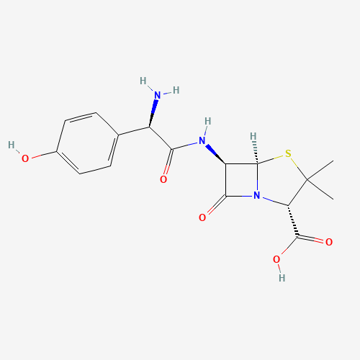

Structure of Amoxicillin

Basic Information of Amoxicillin

Molecular weight | 365.4 g/mol
Molecular formula | C₁₆H₁₉N₃O₅S
Color | White

Indication:

Amoxicillin has FDA approval to treat urinary tract infections, skin, bone, joint infections, prostatitis, typhoid fever, gastrointestinal infections, lower respiratory tract infections, anthrax, plague, and salmonellosis. Infectious diarrhea, typhoid fever, uncomplicated cervical and urethral gonorrhea: oral form only. Nosocomial pneumonia, empiric therapy in febrile neutropenia: IV form only.

Adult patients(MedicineNet, 2016):

Urinary Tract Infections caused by Escherichia coli, Klebsiella pneumoniae, Enterobacter cloacae, Serratia marcescens, Proteus mirabilis, Providencia rettgeri, morganella morganii, Citrobacter diversus, Citrobacter freundii, Pseudomonas aeruginosa, methicillin-susceptible Staphylococcus saprophyticus, or Enterococcus faecalis.

Acute Uncomplicated Cystitis in females caused by Escherichia coli or Staphylococcus saprophyticus.

Chronic Bacterial Prostatitis caused by Escherichia coli or Proteus mirabilis .

Lower Respiratory Tract Infections caused by Escherichia coli, Klebsiella pneumoniae, Enterobacter cloacae, Proteus mirabilis, Pseudomonas aeruginosa, Haemophilus influenzae, Haemophilus parainfluenzae, or penicillin-susceptible Streptococcus pneumoniae. Also,Moraxella catarrhalis for the treatment of acute exacerbations of chronic bronchitis.

Acute Sinusitis caused by Haemophilus influenzae, penicillin-susceptible Streptococcus pneumoniae, or Moraxella catarrhalis.

Skin and Skin Structure Infections caused by Escherichia coli, Klebsiella pneumoniae, Enterobacter cloacae, Proteus mirabilis, Proteus vulgaris, Providencia stuartii, Morganella morganii, Citrobacter freundii, Pseudomonas aeruginosa, methicillin- susceptible Staphylococcus aureus, methicillin-susceptible Staphylococcus epidermidis, or Streptococcus pyogenes.

Bone and Joint Infections caused by Enterobacter cloacae, Serratia marcescens, orPseudomonas aeruginosa.

Complicated Intra-Abdominal Infections (used in combination with metronidazole) caused by Escherichia coli, Pseudomonas aeruginosa, Proteus mirabilis, Klebsiella pneumoniae, orBacteroides fragilis.

Infectious Diarrhea caused by Escherichia coli (enterotoxigenic strains), Campylobacter jejuni
, Shigella boydii ,Shigella dysenteriae, Shigella flexneri or Shigella sonnei when antibacterial therapy is indicated.

Typhoid Fever (Enteric Fever) caused by Salmonella typhi.

Uncomplicated cervical and urethral gonorrhea due to Neisseria gonorrhoeae.

Pediatric patients (1 to 17 years of age):

Complicated Urinary Tract Infections and Pyelonephritis due to Escherichia coli.

NOTE: Although effective in clinical trials, amoxicillin is not a drug of first choice in the including events related to joints and/or surrounding tissues. pediatric population due to an increased incidence of adverse events compared to controls,
To reduce the development of drug-resistant bacteria and maintain the effectiveness of Amoxicillin Tablets and Amoxicillin Oral Suspension and other antibacterial drugs, Amoxicillin Tablets and Amoxicillin Oral Suspension should be used only to treat or prevent infections that are proven or strongly suspected to be caused by susceptible bacteria.

Physiology:

- Mechanism of Action: Amoxicillin belongs to a class of antibiotics called beta-lactams, specifically penicillins. It works by inhibiting bacterial cell wall synthesis. Amoxicillin binds to penicillin-binding proteins (PBPs), which are essential for the cross-linking of peptidoglycan chains in the bacterial cell wall. This disruption weakens the cell wall, leading to osmotic instability and ultimately causing the death of susceptible bacteria through cell lysis.

- Spectrum: Amoxicillin has a broad spectrum of activity and is effective against a wide range of Gram-negative and some Gram-positive bacteria. It is often used to treat urinary tract infections, respiratory tract infections, skin and soft tissue infections, and more.

- Pharmacokinetics: Amoxicillin is absorbed well when taken orally and has good bioavailability. It is distributed widely throughout the body, including in the skin, lungs, kidneys, and prostate. The drug is primarily excreted through the kidneys, and its elimination half-life can vary, but it typically ranges from 3 to 5 hours.

Method of Administration:

Amoxiocillin can be administered through various routes, depending on the type and severity of the infection:

- Oral Administration: Amoxicillin is available in tablet and suspension forms for oral administration. It is usually taken with or without food, as directed by a healthcare provider. It's important to follow the prescribed dosage and complete the full course of treatment, even if symptoms improve before the medication is finished.

- Intravenous (IV) Administration: For severe infections or situations where oral administration is not possible, such as when a patient is unable to swallow, amoxicillin can be administered intravenously. In this case, the drug is diluted and infused slowly into a vein over a specific period as directed by a healthcare professional.

- Ophthalmic and Otic (Ear) Preparations: Amoxicillin is also available as eye drops and ear drops for the treatment of eye and ear infections, respectively. These preparations are administered directly into the affected eye or ear according to the instructions provided.

- Topical Application: Some formulations of amoxicillin are available for topical use, such as creams or ointments for skin infections. These are applied directly to the affected area as directed by a healthcare provider.

Adult Dosage Guidelines:

Dosage for some important bacterial infection is given below (HealthCare 2016)

Urinary Tract: For acute uncomplicated infection the dosage should be 250 mg of amoxicillin for 3 Days within every 12 hours .For Mild/ Moderate infection the dosage should be 250 mg for 7-14 days within every 12 hours.

For severe/complicated infection the dosage should be increased to 500 mg which to be taken for 7-14 days within every 12 hours.

Chronic Bacterial Prostatitis: If the severity of the infection is moderate then the dose should be 500 mg that should be taken for 28 days in every 12 hours

Lower Respiratory Tract: For a moderate infection 500 mg of Amoxicillin must be taken for 7 to 14 days for every 12 hours. And for sever and complicated infection the dose should be to a maximum level of 875 mg that should be taken for 7 to 14 days within every 12 hours.

Bone and Joint: For mild/ moderate infection the dose should be 500 mg that should be taken more than or equal to 4 to 6 weeks and 875 mg should be taken for sever and complicated infection for the same duration as mild/moderate infection.

Adults with Impaired Renal Function: Amoxicillin is eliminated mainly by renal excretion; before that the drug is purified in the liver and intestine through biliary system. So some modification is required for patients with severe renal dysfunction. The patients should be carefully monitored. In patients with severe infections and severe renal impairment, a unit dose of 875 mg may be administered at the intervals noted above.

Patient with Renal Impairment:

As discussed in pharmacokinetics, amoxicillin is primarily eliminated by the renal route; dosage adjustment is required, especially in severe renal impairment.

No dose adjustment is required for creatinine clearance > 50 mL/min/1.73m^2.
For creatinine clearance between 30-49 mL/min/1.73m^2, 250–500 mg every 12 hours is recommended.
For creatinine clearance between 5–29 mL/min/1.73m^2, 250–500 mg every 18 hours is recommended.
For patients on hemodialysis or peritoneal dialysis, 250–500 mg every 24 hours (after dialysis). For patients on CRRT having sepsis, 200 to 400 mg every 8 to 12 hours is recommended.

To calculate the creatinine concentration the given formula should be used: Men: Creatinine clearance (mL/min)
=((Weight (kg) x (140 - age))/(72 x serum creatinine) (mg/dL) Women: 0.85 x the value calculated for men

Adult Dosage Guidelines :

Infection | severity | Dose | Frequency  H= hours Q= every | Duration
Urinary tract | Acute  Mild  Severe | 500 mg  500 mg  875mg | q 12 h  q 12 h  q 12 h | 3 days  7-14 days  7-14 days
Chronic Bacterial Prostatis | Mild/Moderate | 500 mg | q 12 h | 28 days
Lower Respiratory Tract | Mild/Moderate  Severe/Complicated | 500 mg  875 mg | q 12 h  q 12 h | 7-14 days
Acute Sinusitis | Mild/Moderate | 500 mg | q 12 h | 10 days
Skin and Skin Structure | Mild/Moderate  Severe/Complicated | 500 mg | q 12 h  q 12 h | 7-14 days
Bone and Joint | Mild  Moderate | 500 mg  500 mg | q 12 h  q 12 h | ≥ 4 to 6 weeks
Intra Abdominal | Complicated | 500 mg | q 12 h | 7 to 14 days
Infectious Diarrhea | Mild/Moderate/severe | 500 mg | q 12 h | 5-7 days
Typhoid Fever | Mild/Moderate | 500 mg | q 12 h | 10 days
Urethral and Cervical gonococcal Infection | Uncomplicated | 500 mg | Single dose | Single dose
Inhalational anthrax | Indication is based on a surrogate endpoint , | 500 mg | q 12 h | 60 days

Equivalent AUC Dosing Regimens

Amoxocillin Oral Dosage= Equivalent Amoxocillin I.V

Dosage 250 mg Tablet q 12 h = 200 mg I.V .q 12 h

500 mg Tablet q 12 h = 400 mg I.V .q 12 h

875 mg Tablet q 12 h = 500 mg I.V .q 8 h

Pediatric (1 to 17 years) Dosage guidelines for Different Bacterial Infection:

Complicated Urinary Tract: If an intravenous route of administration is taken then the dose should be 6-10 mg/kg (maximum 500 mg per dose and it should never be exceeded more than the maximum level even if the patient is weighting more than 51 kg). The dosage should be taken every 8 hours for 10-21 days. If an oral route is taken then dose for the child should be 10 to 20 mg/kg (maximum 875 mg per dose: it should never be exceeded more than that even if the patient is weighting more than 51 kg). The dosage should be taken every 12 hours for 10-21 days.
Inhalational Anthrax: If an intravenous route of administration should be taken and the dose for the child should be 10 mg/kg (maximum 500 mg per dose). If an oral route of administration is be taken then the dose for the child should be 15 mg/kg (maximum 500 mg per dose). The dosage should be taken every 12 hours for 60 days for both the cases.

Contraindications:

Amoxicillin is contraindicated in patients with a background or history of hypersensitivity towards amoxicillin.

The concomitant dosage of amoxicillin with tizanidine is also contraindicated.
This medication cannot be taken if patient is allergic to antibiotics quinolone class of antimicrobial agents, such as:
- Levofloxacin
- Gemifloxacin
- Moxifloxacin
- Trovafloxacin
- Sparfloxacin

Side Effects:

During a clinical investigation with oral and intravenous administration of amoxicillin in a sample of 49038 patients received the same course of drug. Most of the adverse effect reported were only mild or moderate in severity, which would disappear after the drug was discontinued and it didn't require any treatment. Amoxicillin was discontinued after an adverse event in 1.0% of orally treated patient (Drug Lib, 2009).
Most of the common side affects seen in patient were:
- dizziness
- drowsiness
- headache
- stomach pain
- abdominal pain
- nausea /vomiting
- blurred vision
- nervousness
- anxiety
- agitation and dizziness
- sleep problems (insomnia or nightmares)

Adverse Effects:

Medically important events that occurred in less than 1% of amoxicillin patients are listed below.
Body Pain: headache, abdominal pain/discomfort, foot pain, pain, pain in extremities, injection site reaction (amoxicillin intravenous)

Cardiovascular: palpitation, atrial flutter, ventricular ectopy, syncope, hypertension, angina pectoris, myocardial infarction, cardiopulmonary arrest, cerebral thrombosis, phlebitis, tachycardia, migraine, hypotension

Central Nervous System: restlessness, dizziness, lightheadedness, insomnia, nightmares, hallucinations, manic reaction, irritability, tremor, ataxia, convulsive seizures, lethargy, drowsiness, weakness, malaise, anorexia, phobia, depersonalization, depression, paresthesia, abnormal gait, grand mal convulsion

Gastrointestinal: painful oral mucosa, oral candidiasis, dysphagia, intestinal perforation, gastrointestinal bleeding, cholestatic jaundice, hepatitis HEMIC/LYMPHATIC: lymphadenopathy, petechia
Nutritional: amylase increase, lipase increase

Muscoskeletal: arthralgia or back pain, joint stiffness, achiness, neck or chest pain, flare up of gout.
Renal: interstitial nephritis, nephritis, renal failure, polyuria, urinary retention, urethral bleeding, vaginitis, acidosis, breast pain RESPIRATORY: dyspnea, epistaxis, laryngeal or pulmonary edema, hiccough, hemoptysis, bronchospasm, pulmonary embolism

Renal: interstitial nephritis, nephritis, renal failure, polyuria, urinary retention, urethral bleeding, vaginitis, acidosis, breast pain RESPIRATORY: dyspnea, epistaxis, laryngeal or pulmonary edema, hiccough, hemoptysis, bronchospasm, pulmonary embolism

Skin/Hypersensitivity: Allergic reaction, pruritus, urticaria, photosensitivity, flushing, fever, chills, angioedema, edema of the face, neck, lips, conjunctivae or hands, cutaneous candidiasis, hyperpigmentation, erythema nodosum, sweating

Special Senses: Blurred vision, disturbed vision (change in color perception, over brightness of lights), decreased visual acuity, diplopia, eye pain, tinnitus, hearing loss, bad taste, chromatopsia.

Pregnant Women Warnings: (Amoxicillin)

Amoxicillin is generally considered safe for use during pregnancy and has not been associated with significant risks to the fetus when used at therapeutic doses. Clinical studies and extensive use have not shown evidence of teratogenicity or embryo toxicity in humans.

Animal Studies:
Animal reproduction studies conducted with amoxicillin have not demonstrated harm to the fetus. No evidence of teratogenic effects or adverse developmental outcomes has been observed in animal models.

Human Studies:
Limited data from human studies indicate that amoxicillin is not associated with an increased risk of major congenital malformations, spontaneous abortion, preterm birth, or low birth weight. Observational studies in pregnant women using amoxicillin have shown outcomes similar to those in the general population.

US FDA Pregnancy Category B:
Amoxicillin falls under Category B, meaning that animal reproduction studies have failed to demonstrate a risk to the fetus, and there are no adequate and well-controlled studies in pregnant women.

Precautions:
While amoxicillin is widely regarded as safe during pregnancy, its use should be based on a clear clinical indication. The potential benefits should outweigh any theoretical risks to the fetus. It is commonly prescribed for bacterial infections in pregnancy, including urinary tract infections and respiratory tract infections, when needed.

Amoxicillin Interaction:

Before using Amoxicillin , the doctor should be made aware if we using the following drugs:

- Tizanidine
- Theophylline
- Xanthine Derivatives
- Chelation Complex Formation
- Omeprazole
- Phenytoin
- Oral Antidiabetic Agent
- Metronidazole
- Cyclosporine
- Methotrexate
- Metoclopramide
- NSAIDS
- Ropinirole
- Lidocaine
- Clozapine
- Drugs which prolong QT interval

Pharmacokinetics of Amoxicillin:

1.Absorption:
•Amoxicillin is well absorbed after oral administration, with a bioavailability of approximately 70–90%.
•It is stable in the presence of gastric acid, and food intake does not significantly affect its absorption.

2.Distribution:
•Amoxicillin has a moderate volume of distribution, allowing it to penetrate well into many body fluids and tissues, including the respiratory tract, middle ear, and urinary tract.
• It crosses the placenta and is found in small amounts in breast milk. However, it has limited penetration into the cerebrospinal fluid unless the meninges are inflamed.

3.Metabolism:
•Amoxicillin undergoes minimal hepatic metabolism, with most of the drug remaining in its active form. A small percentage is metabolized to inactive penicillonic acid.

4.Elimination:
•Amoxicillin is primarily eliminated by the kidneys through glomerular filtration and tubular secretion.
•About 60–70% of the administered dose is excreted unchanged in the urine.
•The elimination half-life is approximately 1–1.5 hours in adults with normal renal function. This half-life can be prolonged in individuals with renal impairment, requiring dose adjustments in such cases.

5.Clinical Note:

•Maintaining adequate hydration is recommended to ensure effective renal clearance.
•Its pharmacokinetics make it suitable for frequent dosing (every 8–12 hours) to maintain effective therapeutic levels.

These properties contribute to amoxicillin’s broad-spectrum activity and its effectiveness in treating various bacterial infections, including respiratory, urinary, and skin infections.

Pharmacodynamics of Amoxicillin

Mechanism of Action:

Amoxicillin, a beta-lactam antibiotic in the penicillin class, works by inhibiting bacterial cell wall synthesis. It achieves this through binding to penicillin-binding proteins (PBPs), which are essential enzymes involved in the cross-linking of the peptidoglycan layer in bacterial cell walls. The disruption of this process leads to:
1.Weakened cell wall integrity: The bacterial cell becomes vulnerable to osmotic pressure.
2.Cell lysis and death: Without proper cross-linking, the bacterial cell wall ruptures, resulting in bactericidal action.

Antibacterial Action:

1.Inhibition of Penicillin-Binding Proteins (PBPs):

•Amoxicillin binds to PBPs located on the inner bacterial cell membrane. These enzymes are critical for synthesizing and maintaining the bacterial cell wall.
•By blocking these proteins, amoxicillin halts the synthesis of peptidoglycan, an essential component of bacterial cell walls.

2.Bactericidal Activity:

•Amoxicillin is bactericidal, meaning it kills bacteria rather than merely inhibiting their growth.
•Its action is time-dependent, meaning its effectiveness relies on maintaining concentrations above the minimum inhibitory concentration (MIC) for a sufficient duration.

3.Spectrum of Activity:

•Amoxicillin is active against a wide range of Gram-positive bacteria (e.g., Streptococcus pneumoniae, Enterococcus faecalis) and some Gram-negative bacteria (e.g., Escherichia coli, Haemophilus influenzae).
•It is less effective against beta-lactamase-producing organisms unless combined with a beta-lactamase inhibitor like clavulanic acid.

1.6 Drug Profile: (Vildagliptin)
Vildagliptin is an oral antidiabetic medication used in the treatment of type 2 diabetes mellitus. It belongs to the class of drugs known as dipeptidyl peptidase-4 (DPP-4) inhibitors, also called “gliptins.” Vildagliptin is commonly prescribed as monotherapy or in combination with other antidiabetic agents such as metformin or sulfonylureas to improve glycemic control in adults.

Vildagliptin works by inhibiting the DPP-4 enzyme, which is responsible for the breakdown of incretin hormones such as glucagon-like peptide-1 (GLP-1) and glucose-dependent insulinotropic polypeptide (GIP). These hormones help regulate glucose levels by increasing insulin secretion and decreasing glucagon release in response to meals. By preserving incretin hormone activity, vildagliptin improves the body’s response to meals and reduces fasting and postprandial blood glucose levels.

Chemical Properties:
Vildagliptin is chemically named as (2S)-1-[2-[(3-hydroxyadamantan-1-yl)amino]acetyl]pyrrolidine-2-carbonitrile.
•The molecule contains one hydrogen bond donor and three hydrogen bond acceptor groups.
•The topological polar surface area (TPSA) of vildagliptin is 95.3 Å², which influences its bioavailability.
•The molecular complexity is 270, reflecting its structured design for targeted DPP-4 inhibition.

Proper use of vildagliptin helps control high blood sugar levels, preventing complications such as kidney damage, blindness, neuropathy, and cardiovascular risks associated with poorly managed diabetes.

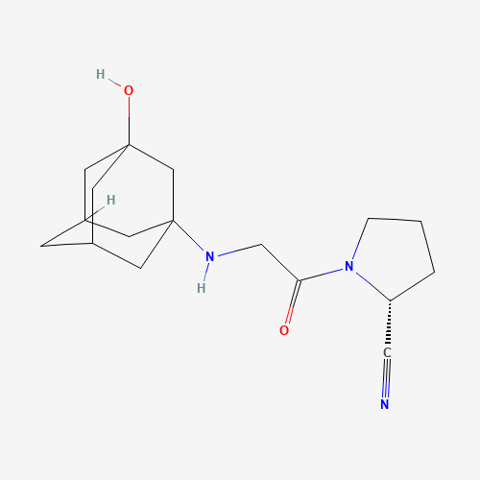

Figure : Structure of Vildagliptin

Basic Information of Vildagliptin

Molecular weight | 303.4 g/mol
Molecular formula | C₁₇H₂₅N₃O₂
Color | White, crystalline powder

Mechanism of Action: Vildagliptin

Inhibition of Dipeptidyl Peptidase-4 (DPP-4):
Vildagliptin works by inhibiting the enzyme dipeptidyl peptidase-4 (DPP-4), which is responsible for breaking down incretin hormones, primarily glucagon-like peptide-1 (GLP-1) and glucose-dependent insulinotropic polypeptide (GIP). These hormones are released by the intestine in response to food intake and play a crucial role in glucose homeostasis.

1.Prolongation of Incretin Hormone Activity:
By inhibiting DPP-4, vildagliptin increases the half-life and bioavailability of GLP-1 and GIP. These hormones stimulate insulin secretion from pancreatic beta cells and suppress glucagon secretion from alpha cells in a glucose-dependent manner.

2.Improved Glucose-Dependent Insulin Secretion:
GLP-1 enhances the responsiveness of beta cells to blood glucose, resulting in increased insulin secretion when blood sugar levels are high. This mechanism ensures glucose regulation without causing hypoglycemia under normal blood sugar conditions.

3.Suppression of Glucagon Secretion:
Vildagliptin reduces the secretion of glucagon, a hormone that promotes hepatic glucose production. Lower glucagon levels result in reduced glucose output from the liver, particularly during fasting or between meals.

4.Improved Fasting and Postprandial Glycemic Control:
By modulating the incretin system, vildagliptin effectively lowers both fasting and postprandial glucose levels, helping to achieve better overall glycemic control.

5.Preservation of Pancreatic Function:
Long-term use of vildagliptin has been shown to help preserve pancreatic beta cell function, which is often compromised in individuals with type 2 diabetes.

Vildagliptin’s mechanism of action is glucose-dependent, meaning its effects are more pronounced when blood sugar levels are elevated, reducing the risk of hypoglycemia compared to some other antidiabetic drugs. This makes it an effective and safe option for managing type 2 diabetes.

Pharmacokinetics:

Pharmacokinetics of Vildagliptin

1.Absorption:
•Vildagliptin is administered orally, typically as a tablet.
•It is rapidly absorbed from the gastrointestinal tract, with peak plasma concentrations occurring approximately 1-2 hours after ingestion.
•The bioavailability of vildagliptin is approximately 85%, and food does not significantly affect its absorption.

2.Distribution:
•Vildagliptin is widely distributed throughout the body, with a volume of distribution (Vd) of around 71 L.
•It is only minimally bound to plasma proteins (about 9-13%), indicating a high level of free drug in circulation.
•It crosses the blood-brain barrier to a small extent, though it is primarily active in peripheral tissues involved in glucose metabolism.

3.Metabolism:
•Vildagliptin is primarily excreted unchanged in the urine, with very limited metabolism.
•Approximately 87% of vildagliptin is excreted in the urine, and the remaining 13% is metabolized in the liver by the cytochrome P450 enzyme system (mainly CYP3A4), resulting in the formation of inactive metabolites.

4.Elimination:
•The elimination half-life of vildagliptin is around 2-3 hours, which is relatively short compared to some other oral antidiabetic medications.
•It is predominantly eliminated unchanged through renal excretion, so kidney function plays a critical role in its clearance.
•In patients with renal impairment, the drug’s elimination may be delayed, requiring dosage adjustments based on the degree of renal dysfunction to prevent potential accumulation and side effects.

Vildagliptin’s pharmacokinetic profile supports its once-daily dosing in most patients, and it is considered to have a low risk for significant drug interactions due to its limited metabolism. However, renal function should be monitored, and dosage adjustments may be necessary for those with impaired kidney function.

Pharmacodynamics:

- Insulin Sensitization: Vildagliptin primarily works by improving the body's sensitivity to insulin. It enhances the response of peripheral tissues (muscles and fat) to insulin, making it easier for these tissues to take up glucose from the bloodstream. This reduces insulin resistance, a hallmark of type 2 diabetes.
- Glucose Regulation: Vildagliptin helps to lower blood glucose levels by reducing the production of glucose in the liver. It inhibits the process of gluconeogenesis, where the liver produces glucose from sources other than dietary carbohydrates. This results in decreased fasting blood sugar levels.
- Glucose Uptake: Vildagliptin also enhances glucose uptake and utilization by cells, particularly in muscles. It stimulates the uptake of glucose into muscle cells, which helps to lower blood sugar levels.
- Reduction of Intestinal Glucose Absorption: Vildagliptin may also reduce the absorption of glucose from the intestines, although this mechanism is less significant compared to its effects on insulin sensitivity and hepatic glucose production.
- Lipid Effects: In addition to its glucose-lowering effects, Vildagliptin can lead to improvements in lipid profiles. It may lower triglyceride levels and increase high-density lipoprotein (HDL) cholesterol.
- Weight Effects: Vildagliptin is often associated with modest weight loss, which can be beneficial for individuals with type 2 diabetes, as it may help improve insulin sensitivity and metabolic parameters.

Therapeutic use:
Vildagliptin is a medication commonly used to treat a medical condition called type 2 diabetes mellitus. It is an oral antidiabetic drug that helps lower blood sugar levels in people with this condition. Vildagliptin is typically prescribed in combination with lifestyle changes such as diet and exercise.
Here are the primary therapeutic uses of Vildagliptin:
- Type 2 Diabetes Management: Vildagliptin is a first-line treatment for type 2 diabetes. It works by improving the body's sensitivity to insulin, reducing the amount of glucose produced by the liver, and increasing the uptake of glucose by cells in the body. This helps lower blood sugar levels and improves glycemic control.
- Prediabetes: Vildagliptin may also be prescribed for individuals with prediabetes, a condition in which blood sugar levels are higher than normal but not yet in the diabetic range. It can help reduce the risk of progression to type 2 diabetes in some cases.

Side Effects:
- Gastrointestinal Issues:
  - Nausea
  - Vomiting
  - Diarrhea
  - Abdominal discomfort or cramping
  - Gas or bloating
- Taste Disturbances: Vildagliptin can sometimes cause a metallic or bitter taste in the mouth.
- Vitamin B12 Deficiency: Long-term use of Vildagliptin may lead to a deficiency in vitamin B12,
which can result in anemia, neuropathy, and other complications.
- Hypoglycemia (Low Blood Sugar): Vildagliptin alone is not known to cause low blood sugar (hypoglycemia), but it can increase the risk of hypoglycemia when used in combination with other diabetes medications that lower blood sugar.
- Skin Reactions: Some people may experience skin reactions such as itching or rash while taking Vildagliptin.

Chapter –2 Literature Review

Literature Review:

International Journal of Pharmaceutical and Life Sciences ISSN 2305-0330 Volume 1, Issue 4, Serial 3: November 2014

In-vitro interactions of Amoxicillin with different essential mineral salts and its influence on antimicrobial activity (MIC) of Amoxicillin.

Sajjad hossain,Rafiq chowdhury, Maria jannat, Sobuj hossain, Akram Chowdhury,

University, Dhaka, Bangladesh. Department of Pharmacy,East West University,

Abstract

Present work describes the interactions of Amoxicillin with different essential mineral salt like Magnesium Sulfate, Manganese Sulfate, Ferrous Sulfate, Zinc Sulfate and Potassium Chloride in an aqueous system at pH 7.4. This Magnesium Sulfate, Manganese Sulfate, Ferrous Sulfate, Zinc Sulfate and Potassium Chloride are essential trace element. From spectrophotometric study, it has been found that Amoxicillin forms 1:1 complex with Magnesium Sulfate, Manganese Sulfate, Ferrous Sulfate, Zinc Sulfate and Potassium Chloride. Spectral studies helps to detect the initial complexation between drug and mineral salts. Job's plot at 7.4 provides same type of information. An individual antimicrobial study (MIC) of Amoxicillin Hydrochloride in 1:1 mixture with Magnesium Sulfate, Manganese Sulfate, Ferrous Sulfate, Zinc Sulfate and Potassium Chloride at pH 7.4 was performed. These studies were carried out by observing the minimum inhibitory concentration (MIC) of the complexes and compared with the parent Amoxicillin against both Gram negative and Gram positive microorganisms in nutrient broth medium. Study confirms interactions of the amoxicillin with Magnesium Sulfate, Manganese Sulfate, Ferrous Sulfate, Zinc Sulfate and Potassium Chloride and the interactions results into change the antimicrobial activity of amoxicilin. Result shows that the antimicrobial activity increasing trends in presence of Magnesium Sulfate, Manganese Sulfate, Ferrous Sulfate and decreasing trends in presence of Zinc Sulfate and Potassium Chloride. Key words: Amoxicillin, Job's Plot.

Academic Sciences; Vol 4, Issue 3, ISSN-0975-1491, 2012

Application of UV spectrophotometric methods for estimation of Amoxicillin and Tinidazole in combined tablet dosage form.
SWAPNIL R. BHALERAO*

Department of Pharmaceutical Chemistry, Mahatma Gandhi Vidya Mandir's Pharmacy College,
Panchavati, Mumbai - Agra Road, Nashik- 422003, Maharashtra.
AMBADAS R. ROTE

Department of Pharmaceutical Chemistry, Mahatma Gandhi Vidya Mandir's Pharmacy College, Panchavati, Mumbai - Agra Road, Nashik- 422003, Maharashtra.

Abstract

Two simple, sensitive, rapid, accurate and precise simultaneous UV-spectrophotometric methods have been developed and validated for the estimation of amoxicillin and tinidazole in bulk and combined tablet dosage form. The first method is based on simultaneous equation, for the determination of sampling wavelengths, each of amoxicillin and tinidazole were scanned in the Wavelength range of 200-400 nm in spectrum mode and sampling wavelengths were selected for analysis were 228.71 (λ max of amoxicillin) and 310 (λ max of tinidazole) respectively in methanol: water (50:50%v/v). Beer's law obeyed in the concentration range of 2-16μg/ml for the both drugs. The second method based on measurement of absorbance at isoabsorptive point at 291 nm. Beer's law obeyed in the concentration range of 2-16μg/ml for the both drugs. The correlation coefficients and mean recoveries were found satisfactory by both methods. The proposed methods can be successfully applied for simultaneous estimation of amoxicillin and tinidazole (SWAPNIL R. BHALERAO*, 2012).

  - In Vitro Antibacterial Studies of Amoxicillin-imines and Their Complexes with Ca(II), Ni(II), Co(II), and Zn(II)
Muhammad Imran, Javed Iqbal, Shahid Iqbal, Nazia Ijaz

Undergraduate Block, University of the Punjab, Lahore - PAKISTAN 2 Institute of Chemistry. Punjab University, Lahore- PAKISTAN 3 Department of Chemistry, University of Sargodha, Sargodha- 40100- PAKISTAN

Abstract

Some new transition metal complexes of amoxicillin-imines derived from amoxicillin and p- substituted anilines were synthesized and characterized on the basis of physical properties, conductance measurements, elemental analysis, UV/Vis., infrared and nuclear magnetic resonance spectroscopy. These ligands as well as their metal complexes were also evaluated for their antibacterial activity against several bacterial strains, such as Staphylococcus aureus, Bacillus subtilus, Salmonella typhae, and E. coli. It was found that metal complexes are more antibacterial as compared to uncomplexed ligands. The present study was carried out in search of a target antibiotic instead of a broad spectrum one (Muhammad IMRAN1, 2007)

International Journal of Analytical and Bioanalytical Chemistry, ISSN-2231-5012

Development and antidiabetic drug of a simple and economical spectrofluorimetric method for estimation of amoxicillin in pharmaceutical dosage forms

Serigne Omar SARR, Serigne Momar NDIAYE, Djibril FALL, Adama DIEDHIOU, Amadou DIOP, Bara NDIAYE, Yérim Mbagnick DIOP
Laboratoire National de Contrôle des Médicaments, 39, Avenue Pasteur, BP 6303, Dakar-étoile, Sénégal.

Laboratoire de Chimie Analytique et Bromatologie, Faculté de Médecine, de Pharmacie et d'Odontologie, Université Cheikh Anto DIOP de Dakar, BP 5005 Dakar-1 cm. Sénégal Laboratoire de Chimie Organique et Thérapeutique, Faculté de Médecine, de Pharmacie et Odontologie, Université Cheikh Anta DIOP de Dakar, RP 5005 Dakar Tamm, Sénéga

Abstract

A new simple, precise, accurate and "green" spectrofluorimetric method for the determination of amoxicillin both as a bulk drug and in pharmaceutical formulations was developed and validated using water as solvent. At a predetermined excitation wavelength (228.71 nm) and emission wavelength (450 nm), it was proved linear in the concentration range of 20-250 ng/ml, exhibited good correlation coefficient (R2 = 0.9993) and excellent mean recovery (98.40-102.26%). The results of the recoveries studies showed that the method was not affected by the presence of common excipients. The method was applied for the analysis of the drug in the pure, tablet and injectable forms. The method was validated for various parameters according to ICH guidelines. LOD and LOQ for amoxicillin were found to be 4.53 ng/mL, and 5.67 ng/mL respectively. The method has been successfully applied for the analysis of marketed formulations available in Senegal (Serigne Omar SARR1, 2021).

Clinical Infectious Diseases, Vol. 22, No. 2 (Feb., 1996), pp. 251-256; Published by: Oxford University Press
Effect of Amoxicillin on the Pharmacokinetics and Pharmacodynamics of Warfarin

Debra S. Israel, Jennifer Stotka, William Rock, Charles D. Sintek, Alan K.Kamada, Catherine Klein, William R. Swaim, Robert E. Pluhar, John P. Toscano, John T.Lettieri, Allen H. Heller and Ron E. Polk

From the Department of Pharmacy and Pharmaceutics, Medical College of Virginia, Virginia Commonwealth University, Richmond, Virginia; Lilly Research Laboratories, Eli Lilly and Company, Indianapolis, Indiana; the Department of Pharmacy, Veterans Affairs Medical Center, and the clinical Pharmacology Division, Department of Pediatrics and the Department of Internal Medicine, National Jewish Center for Immunology and Respiratory Medicine, Denver, Colorado; the Department of Laboratory Medicine and Pathology and the Department of Pharmacy , Veterans Affairs Medical Center, Minneapolis, Minnesota; and the Pharmaceutical Division, Bayer, West Haven, Connecticut

Abstract

To determine if amoxicillin therapy alters the response to warfarin treatment, 36 adult patients attending three university-affiliated outpatient anticoagulation clinics randomly received a 12-day course of amoxicillin (750 mg twice daily) and a 12-day course of placebo; each course was separated by a 2- week washout period. Prothrombin times (PTS), concentrations of S-warfarin and R-warfarin (the isomers of warfarin), and concentrations of clotting factors II and VII were determined three times weekly for 9 weeks. By day 12 of amoxicillin therapy, concentrations of S-warfarin remained unchanged compared with those after placebo therapy, but R-warfarin concentrations increased significantly (1.15 times those after placebo therapy; P = .001) concentrations of clotting factors II and VII decreased (0.903 and 0.872

times those after placebo therapy, respectively, PS .020). The mean PT ratio after 12 days of amoxicillin therapy increased slightly (1.032 times that after placebo therapy; P = .057), but no patient had bleeding or a change in PT that required alteration in warfarin or amoxicillin therapy. We conclude that warfarin therapy is not a contraindication to the use of amoxicillin.

Reviews of Infectious Diseases, Vol. 10, No. 3 (May - Jun., 1998), pp. 516-527; Published by:
Oxford University Press
Amoxicillin: In Vitro Activity, Mechanism of Action, and Resistance.

Christine C. Sanders from the Department of Medical Microbiology, Creighton University School of Medicine, Omaha, Nebraska

Amoxicillin is a widely used beta-lactam antibiotic in the aminopenicillin class that exhibits broad-spectrum antibacterial activity. At concentrations of ≤2 µg/mL, it is highly active against most gram-positive bacteria, including Streptococcus species, Enterococcus faecalis, and non-beta-lactamase-producing strains of Staphylococcus aureus. Among gram-negative bacteria, amoxicillin is effective against Haemophilus influenzae, Escherichia coli, Proteus mirabilis, and Salmonella species, provided these organisms do not produce beta-lactamase enzymes. However, obligate anaerobes such as Bacteroides fragilis are often resistant unless paired with beta-lactamase inhibitors.

Amoxicillin exerts its bactericidal action by inhibiting bacterial cell wall synthesis. It specifically targets penicillin-binding proteins (PBPs), leading to the disruption of peptidoglycan cross-linking and subsequent bacterial lysis. The antibiotic’s effectiveness depends on the time its concentration remains above the minimum inhibitory concentration (MIC) for the targeted pathogen, emphasizing its time-dependent pharmacodynamics.

Resistance to amoxicillin is primarily mediated by the production of beta-lactamases, which hydrolyze the beta-lactam ring, rendering the drug ineffective. Other mechanisms include alterations in PBPs (e.g., in methicillin-resistant Staphylococcus aureus [MRSA]) and reduced permeability through bacterial outer membranes. To counteract resistance, amoxicillin is often combined with beta-lactamase inhibitors such as clavulanic acid.

The antimicrobial spectrum, coupled with its ability to penetrate tissues and its oral bioavailability, makes amoxicillin an essential agent in the treatment of various infections.

British Medical Journal (Clinical Research Edition), Vol. 296, No. 6629 (Apr. 16, 1988)
Danger of Interaction Between Amoxicillin and Theophylline.

Drs. J. L. Bem and R. D. Mann (Committee on Safety of Medicines, London SW8 5NQ) write:

Amoxicillin, a commonly used broad-spectrum penicillin antibiotic, is prescribed for various bacterial infections. While amoxicillin is generally well-tolerated and lacks significant interactions with most medications, co-administration with theophylline (a methylxanthine used to treat respiratory conditions like asthma and COPD) warrants caution.

Although no widespread or severe interaction between amoxicillin and theophylline has been established, reports suggest the potential for mild alterations in theophylline plasma levels in some patients. Early signs of theophylline toxicity—nausea, vomiting, and restlessness—could be overlooked or mistaken for amoxicillin side effects, especially in patients on long-term theophylline therapy.

The Committee on Safety of Medicines has received a small number of reports of adverse reactions when these drugs were used together. In most cases, the drug dosages were within the recommended ranges, yet symptoms appeared within a few days of co-administration.

Though this interaction is not consistent across all patients, clinicians should be cautious, particularly in elderly patients or those with pre-existing conditions that may alter drug metabolism. If concurrent use of amoxicillin and theophylline is deemed necessary, monitoring plasma theophylline concentrations is advisable to avoid toxic levels.

Additionally, patients should be advised against self-medication with over-the-counter cough or cold remedies that may contain theophylline derivatives.

In summary, while amoxicillin is generally safe, healthcare professionals should remain vigilant when prescribing it alongside theophylline and consider alternative antibiotics when possible.

Chapter-3 Aim of the Work

Aim of the Work:

The principal aim of the present study was to probe the in vitro interactions of Amoxicillin with Vildagliptin and to determine the antimicrobial activity of amoxicillin after drug drug interactions at pH 1.75

Aim of the present works listed below:
- To study drug-drug interactions and the nature of the interactions.
- To determine the antimicrobial activity as Amoxicillin as an antimicrobial agent.
- To find quantitative interaction of amoxicillin with Vildagliptin .

- To find whether the interaction of drug with amoxicillin effect the antimicrobial activity of amoxicillin .

Chapter-4 Materials and Method

4. Material and Methods

1. Chemical and reagents:

All the chemicals used here were analytical grade and were sorted under optimum storage conditions. The experimental mixtures and solutions were prepared in standard volumetric flasks about one hour prior to recording the data.
List are given below:

Sl.  No. | Name | Source
1 | Amoxicillin | Gift samples from Albion Laboratories Limited
2 | Vildagliptin | Gift samples from Albion Laboratories Limited
3 | Demineralized water | Taj scientific
4 | Nacl | USTC, Foy’s lake, Chittagong, dept. of pharmacy
5 | Concentrated Hcl | USTC, Foy’s lake, Chittagong, dept. of pharmacy

4.2 Instruments and equipments:
All the equipment’s and instruments used throughout the study are given in the following table along with their source.

List are given below:

Name | Model | Source
pH Meter | pH -211 | Hanna, Romania
UV spectrophotometer | T80 | PG instrument ltd, England
Electronic balance | AL-204 | Mettler toleddo, Switzerland
pipette

4.3 Methods:

Preparation of stock solution:
Amoxicillin solution 100 ml of 1×10 ̄5 was prepared by dissolving 0.36541 gm of Amoxicillin in 100 ml of volumetric flask. The stock solution was diluted to desired strength by buffer solution.

Preparation of Drug solution:
Vildagliptin solution 100 ml of 1×10 ̄5 was prepared by dissolving 0.3034 gm of Vildagliptin in 100 ml of volumetric flask.

Preparation of Buffer solition:

To prepare buffer solution 2 gm of Nacl was dissolved in demineralized water with 7 ml of concentrated HCL and pH was adjusted to 1.75 and the volume was made to 1000 ml with the same solution.

Preparation of Standard curve of Amoxicillin :

Amoxicillin’s stock solution at pH 1.75 and concentration of 1×10 ̄5 was added in different concentrations to nine test tubes, to have the following concentrations : 9×10 ̄ 5 8×10 ̄ 5 7×10 ̄ 5 6×10 ̄ 5 5×10 ̄ 5 4×10 ̄ 5 3×10 ̄ 5 2×10 ̄ 5 1×10 ̄ 5

The solutions were then properly mixed . The absorbance values of the solutions were determined at 228.71 nm by UV spectrophotometer. As a control of reference sample, acidic buffer solution of pH 1.75 was used. The standard curve was obtained by plotting the absorbance values against the corresponding concentrations.

Image of the Sample preparation:

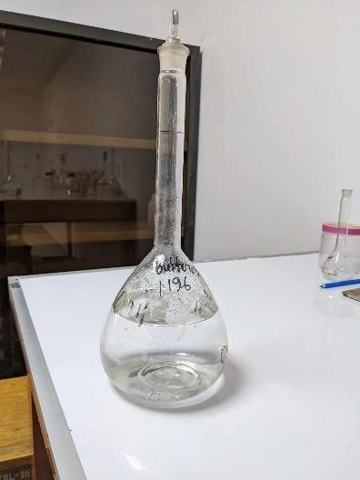
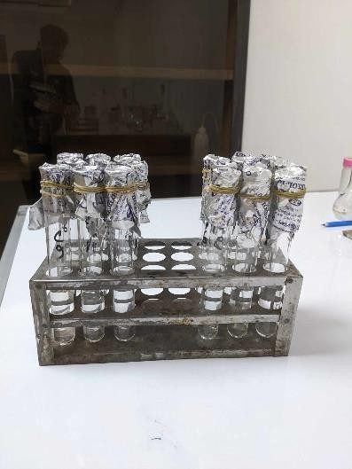
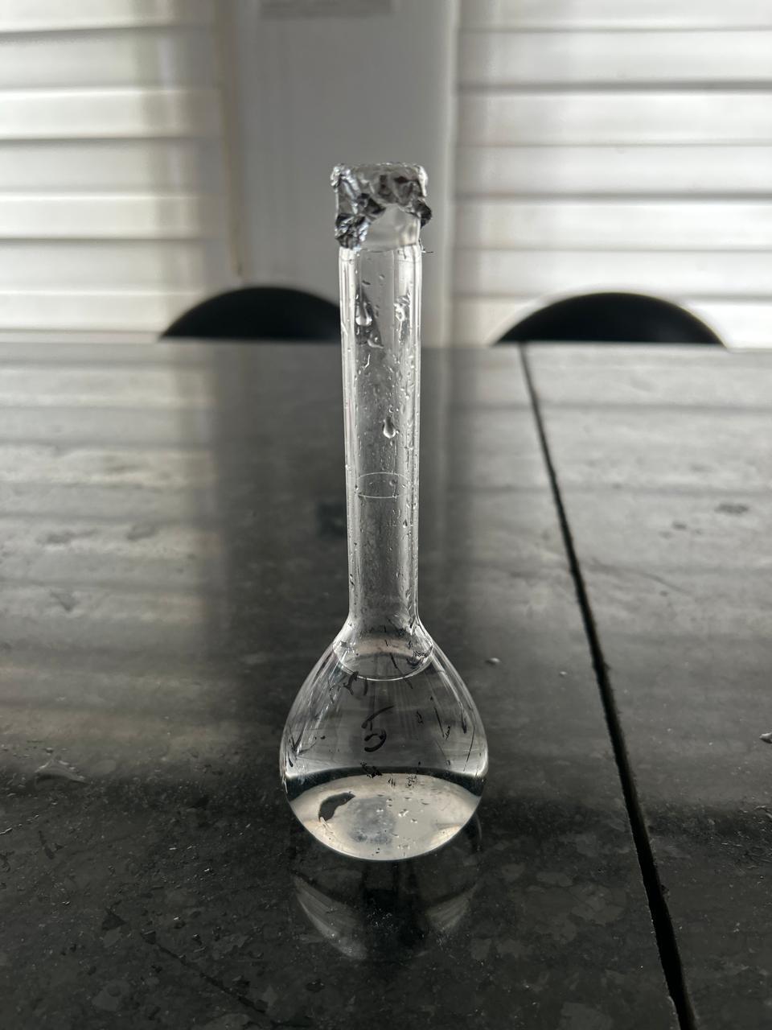

Standard curve of Amoxicillin :

M x 10⁻⁵ | Absorbance
1 | 0.169
2 | 0.213
3 | 0.251
4 | 0.301
5 | 0.351
6 | 0.391
7 | 0.419
8 | 0.456
9 | 0.491

Fig: Standard curve of Amoxicillin

From the above fig we can observe that the absorbance of Amoxicillin increases with increasing concentration according to Beer Lamberts Law.

Absorbance of Amoxicillin at different wavelength :

Wavelength | Absorbance
200 | 0.0059
225 | 0.0147
245 | 0.1823
265 | 0.5964
285 | 0.5221
305 | 0.3582
325 | 0.5471
345 | 0.3007

Fig: Absorbance at different wavelength
From the above fig we can observe that the absorbance of Amoxicillin varies at different wavelength.

Chapter –5 Results and Discussion

Result and discussion:
Spectral studies of interaction of Amoxicillin with Vildagliptin :

Wave length (nm) | Absorbance of Amoxicillin | Absorbance of Amoxicillin + Vildagliptin
200 | 0.169 | 0.0188
225 | 0.213 | 0.0083
245 | 0.251 | 0.4531
265 | 0.301 | 0.6724
285 | 0.351 | 0.7555
305 | 0.391 | 0.3132
325 | 0.419 | 0.5118
345 | 0.456 | 0.4912

. Amoxicillin . Vildagliptin

Fig: Spectral plot of drug and drug with Vildagliptin

From the above fig we can observe that the absorbance of Amoxicillin is different when it interact with Vildagliptin

Effect of Drug on Amoxicillin by Job’s method of continuous variation:

The molar ratios of the complexes of amoxicillin with drugs were estimated by job's method of continuous variation. The observed absorbance values were measured in pH 1.75 at various concentration (1×10 ̄ 5 to 9×10 ̄ 5) of amoxicillin and Vildagliptin at 228.71 nm. The Job's plots at pH 1.75 were obtained by plotting absorbance difference against the mole fraction of the drug (amoxicillin ) which are presented in the following table.

Values of job plot of Amoxicillin and Vildagliptin :

Concentration of Amoxicillin  5×10 ̄5M | Absorbance of Amoxicillin  A | Concentration of Vildagliptin  5×10 ̄5M | Absorbance of Vildagliptin  B | Absorbance of mixture  C | Absorbance difference  D=(A+B)-C
1 | 0.169 | 9 | 0.611 | 0.256 | 0.524
2 | 0.213 | 8 | 0.609 | 0.205 | 0.617
3 | 0.251 | 7 | 0.604 | 0.176 | 0.676
4 | 0.301 | 6 | 0.602 | 0.154 | 0.749
5 | 0,351 | 5 | 0.600 | 0.136 | 0.815
6 | 0.391 | 4 | 0.599 | 0.235 | 0.755
7 | 0.419 | 3 | 0.595 | 0.256 | 0.758
8 | 0,456 | 2 | 0.591 | 0.311 | 0.736
9 | 0.491 | 1 | 0.589 | 0.326 | 0.754

Fig: Absorbance difference of Amoxicillin and Vildagliptin

From the above figure we can observe that Amoxicillin forms strong 1:1 complexes with Vildagliptin which is indicated as ‘˄’ shaped curve. This ‘˄’ shaped curve confirms the interaction between drug and drugs.

Chapter-6 Antimicrobial study

Introduction:
The antimicrobial screening, which is the first stage of antimicrobial drug research, is performed to ascertain the susceptibility of various bacteria to any agent. This test measures the ability of each test sample to inhibit bacterial growth in vitro.
There is no standardized method for expressing the result of antimicrobial screening. Some investigator uses the diameter of zone of inhibition and the minimum weight of extract to inhibit the growth of microorganism. However, a great number of factor viz, the extraction methods, inoculums volume, culture medium composition, pH and incubation temperature can influence the results.
Amoxicillin is a antimicrobial drug. It works well against E.coli.

Material and Method:

Principle of Disc Diffusion Method:
Solution of known concentration (3μg/ml) of the test samples are made by dissolving measured amount of the samples in calculated volume of solvents. Dried and sterilized filter paper discs (6 mm diameter) are then impregnated with known amounts of the test substances using micropipette. Discs containing the test material are placed on nutrient agar medium uniformly seeded with the test microorganism, Standard antibiotic discs and blank discs (impregnated with solvent) are used as positive and negative control. These plates are then kept at low temperature (4 °C) for 24 hours to allow maximum diffusion. During this time dried discs absorb water from the surrounding media and then the test materials dissolve and diffuse out of the sample disc. The diffusion occurs according to the physical law that controls the diffusion of molecules through agar gel. As a result there is a gradual change of test materials concentrations in the media surrounding the disc. The plate are then incubated at 37 °C for 24 hours to allow maximum growth of the organism. If the test materils have any antimicrobial activity, it will inhibit the growth of the micoorganisms and a clear zone of inhibition will be visualized surrounding the medium. The antimicrobial activity of the test agent is determined by measuring the diameter of zone of inhibition expressed in millimeter. The experiment is carried out more than once and the mean of the readings is required.

Apparatus and Reagent:

Filter paper disc Petri dishes
Inoculating loop Sterile cotton
Sterile forceps Micropipette
Screw cap test tubes
Nose mask and Hand gloves Laminar air flow hood
Autoclave Incubator Refrigerator
Nutrient Agar Medium Acetone
Methanol

Test Organism:
- Staphylococcus aureus.
- E. coli

Test sample:
- Sample of Amoxicillin
- Mixture of Amoxicillin and Vildagliptin

Culture medium:
Nutrient agar medium was used to demonstrate the antimicrobial activity and to make subculture of the test organism.
Composition of Nutrient Agar media (1000 ml)

Ingredients | Amounts(gms/liter)
Beef extract | 5.0
Peptic digest of animal tissue | 5.0
Yeast extract | 1.50
Distilled water | q.s to 1000ml
pH | 7.2±0.1 at 25°C

Preparation of media:
To prepare required volume of nutrient agar medium of each of the constituents was calculated from the composition chart for 1000ml and required amounts were taken in conical flask by weighing them separately. Distilled water was added to make the final volume. Then boiled in magnetic stirrer for 15 minutes till complete dissolution. The conical flasks were then plugged with cotton and sterilized in an autoclave at temperature 121°C and a pressure of 15 lbs/sq inch for 30 minutes. The media was then transferred in 20 ml and 5 ml. respectively to prepare plates and slants under aseptic conditions, in a number of required test tubes. Then kept at water bath to reduce the temperature to 45-50°C. These slants were used for making fresh culture of microorganism, which in turn was used for sensitivity test.

Preparation of sub-culture:
With the help of an inoculating loop, the test organism from the pure cultures were transferred to the agar slants in an aseptic condition. The inoculated slants were then incubated at 37°C for 18 to 24 hrs to assure the growth of test organism. This culture was used after one day.

Preparation of the test plates:

The test organism were transferred from the subculture to the test tube containing 20 ml autoclaved media with the help of an inoculating loop in an aseptic area. The test tube was shaken by rotation to get an uniform suspension of the organism. The bacterial suspensions were immediately transferred to sterile petri dishes in an aseptic laminar air flow cabinet. The petri dishes were rotated several times, clockwise and then anti-clockwise, to assure homogenous distribution of the test organisms. The media were poured into petri dishes in such a way as to give uniform depth of approximately 4mm. After the medium had cooled to room temperature, it was stored in a refrigerator (4°C).

Preparation of disks:
Three types of disks were prepared for antibacterial screening. These were:

Sample disks:
Sterilized filter paper disks (5mm diameter) were taken in a blank petri dish. Sample solution of desired concentration was applied on the disks with the help of a micropipette in an aseptic condition. The disks were left for a few minutes in aseptic condition for complete removal of solvent. For complexes 0.5mg/disk were used.

Standard disks:
These are used to compare the antibacterial activity of test material. Amoxicillin disk (0.03mg.disk) was used as a standard.

Blank disks:
These were also prepared in order to determine the antibacterial activity of the solvents used.

Preparation of test sample ( or sample solution):
The test sample was prepared by dissolving amoxicillin (0.01 mg each) and Amoxicillin + Vildagliptin ( 0.01 mg each) in 2 different vials containing 2 ml of methanol 50 μl of solution used in each disk.

Placement of disk, diffusion and incubation
The sample disks impregnated separately with the test material and standard antibiotic disk were placed gently on the solidified agar plates freshly seeded with test organism with the help of a sterile forceps to assure complete contact with medium surface. The spatial arrangement of the disks was such that the disks were no closer than 15 mm to the edge of the plate and for enough apart to prevent overlapping the zones of inhibition. The plates were then inverted and kept in a refrigerator for about 24 hrs. at 4°C. This is sufficient time for the material to diffuse to considerable area of the medium. Finally, the plates were incubated at 37°C for 24 hrs.

Determination of antimicrobial activity by the zone of inhibition
The antimicrobial potency of the test agents is measured by their activity to prevent the growth of the microorganisms surrounding the discs which gives clear zone of inhibition. After incubation, the antimicrobial activities of the test materials were determined by measuring the diameter of the zones of inhibition in millimeter with a transparent millimeter scale.

Results:

- Amoxicillin does works well against Staphylococcus aureus. It is a gram positive bacteria.
- Amoxicillin’s antibiotic activity reduces when interact with Vildagliptin .
- Amoxicillin does works against E. coli . It’s a gram negative bacteria.

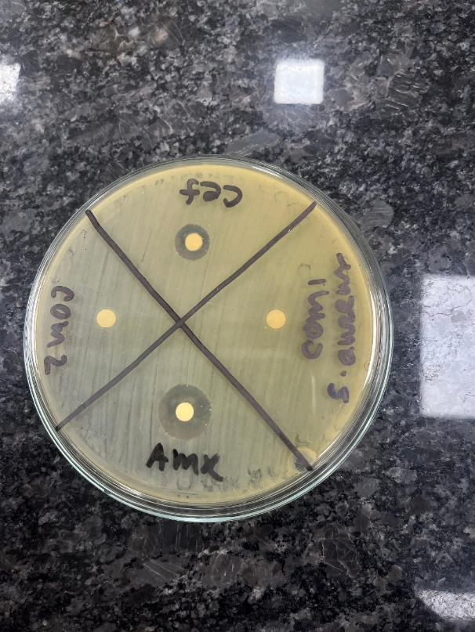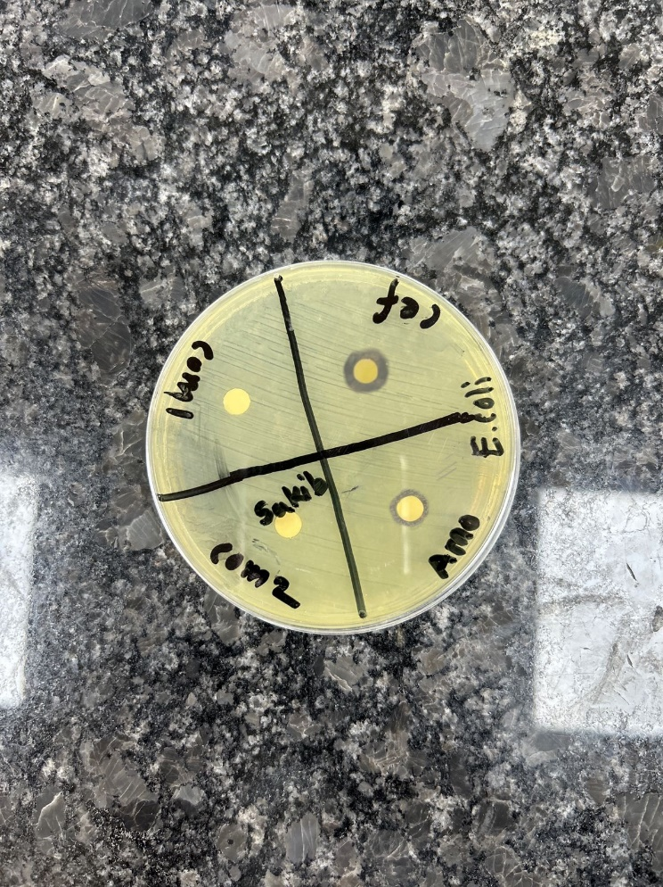

In the figure-
C= Drug (Amoxicillin ) C+M =Drug + Vildagliptin

Evaluation of antimicrobial study of Amoxicillin with Vildagliptin :

Bacteria used | Standard disk (zone of inhibition/mm) | Sample disk (zone of inhibition)
Staphylococcus aureus | 14 mm | Amoxicillin
 |  | 7 mm
Staphylococcus aureus | 14 mm | Amoxicillin + Vildagliptin
 |  | No zone of inhibition
E. coli | 14 mm | Amoxicillin + Vildagliptin
 |  | No zone of inhibition

Chapter-7 Conclusion

Conclusion

In the present work, the interaction of an important antimicrobial drug, Amoxicillin with Vildagliptin at pH 1.75 by a variety of physical method like inspection of spectral behavior, Job’s method of continuous variation.
From spectral study, it has been seen that Amoxicillin gives a sharp peak at 228.71 nm. When
Vildagliptin with Amoxicillin at 1:1 ratio, the intensity of the peak changes remarkably.
From the job plot we can see that Amoxicillin forms strong 1:1 complexes Vildagliptin which is indicated as ‘˄’ shaped curve. This ‘˄’ shaped curve confirms the interaction.
To sum up, we can say that the antimicrobial activity of Amoxicillin decreases when it reacts with Vildagliptin

References
- Shargel L. Comprehensive pharmacy review. Lippincott Williams & Wilkins,; 2010.

- Herfindal ET, Hirschman JL. Clinical pharmacy and therapeutics. Williams & Wilkins; 1979 Dec 1.

- (2023, september 25). Retrieved from Drug interaction: https://hivinfo.nih.gov/understanding-hiv/fact-sheets/what-drug- interaction#:~:text=Key%20Points,may%20cause%20an%20unwanted%20reaction

- Amoxicillin (2024, september 25). Retrieved from Drug bank:https://pubchem.ncbi.nlm.nih.gov/compound/L-Amoxicillin

- Group, A. E. (2010). Amoxicillin Pregnancy and Breastfeeding Warnings. Retrieved from https://www.drugs.com/

- https://www.drugs.com/pregnancy/amoxicillin.html

- HealthCare, B. (2016, 7 26). CIPRO®. Retrieved from http://www.accessdata.fda.gov/:

- Information, N. C. (n.d.). 86393-32-0. Retrieved July 22, 2016, from https://pubchem.ncbi.nlm.nih.gov/

- Vildagliptin. (2023, september 25). Retrieved from Pubchem: https://pubchem.ncbi.nlm.nih.gov/compound/Vildagliptin

- Vildagliptin. (2023, september 27). Retrieved from MedicineNet: https://www.medicinenet.com/search/mni/Vildagliptin%20hydrochloride

- Pharmacokinetics and pharmacodynamics of Vildagliptin. (2023, september 30). Retrieved from ACCP: https://accp1.onlinelibrary.wiley.com/doi/abs/10.1177/009127009603601105

- https://pubchem.ncbi.nlm.nih.gov/compound/62998 Joseph P Remington, P. B. (2013).
The science and practise pharmacy. 22nd Edition

- Swapnil r. Bhalerao*, a. R. (2012, 04). Application of uv spectrophotometric methods for estimation of amoxicillin and tinidazole in combined tablet dosage form. Retrieved 2016, from http://www.ijppsjournal.com/:

- Serigne Omar SARR1, 2. S. (2013, 07). Development and validation of a simple and economical spectrofluorimetric method for estimation of amoxicillin in pharmaceutical dosage forms. Retrieved 08 8, 2016, from http://urpjournals.com/:

- Tendencia, E. A. Chapter 2. Disk diffusion method. In Laboratory manual of standardized methods for antimicrobial sensitivity tests for bacteria isolated from aquatic animals and environment (pp. 13-29). Tigbauan, Iloilo, Philippines: Aquaculture Department, Southeast Asian Fisheries DevelopmentCenter,2004.[cited 2 august 2017]. Available at: http://hdl.handle.net/10862/1635

- Dajcs JJ, Thibodeaux BA, Marquart ME, Girgis DO, Traidej M, O'Callaghan RJ. Effectiveness of amoxicillin, levofloxacin, or moxifloxacin for treatment of experimental Staphylococcus aureus keratitis. Antimicrobial agents and chemotherapy. 2004 Jun 1;48(6):1948-52.

- Tendencia, E. A. Chapter 2. Disk diffusion method. In Laboratory manual of standardized methods for antimicrobial sensitivity tests for bacteria isolated from aquatic animals and environment (pp. 13-29). Tigbauan, Iloilo, Philippines: Aquaculture Department, Southeast Asian Fisheries DevelopmentCenter,2004.[cited 2 august 2017]. Available at: http://hdl.handle.net/10862/1635

- BSAC Methods for Antimicrobial Susceptibility Testing. Mandy Wootton. Version 12 May. 2013. Available from: http://bsac.org.uk/wp-content/uploads/2012/02/Version-12- Apr-2013. [Accessed 28th July, 2017].

